House Rent Receipt

Date: 02nd June 2022

This is to acknowledge the receipt from Madhuri Rallabhandi the sum of rupees (8332*12)= 99,984 in INR by cash towards house rent of Address LIG-675,bharathi Nagar, BHEL,RC Puram, Lingampally, Hyderabad-502032 for the months from April 2022 to March 2023

Landlord's Address:
Somayaji D.,
First floor,
Single Building,
LIG-675,
Bharathi Nagar,
BHEL,
RC Puram,
Lingampally,
Hyderabad-502032 Landlord's Signature
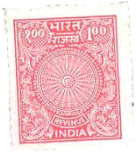

Somayaji D.
Date : 02-06-2022
Place: Hyderabad

